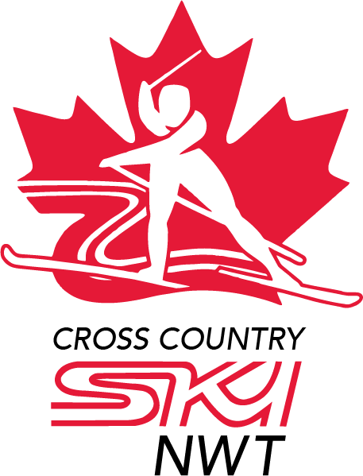

Cross Country NWT

Post Secondary NWT Skiers Grant Application

2021-22 Season

Cross Country NWT (CCNWT) is pleased to offer a grant to NWT skiers who are both a) pursuing post secondary education, and b) cross country skiing at specific competitive events.

Please ensure that you have read the Policy Support for Post Secondary NWT Skiers in advance of filling out this application form to ensure you are eligible for the Grant.

For 2021-22, the Grant will have minimum value of $200 and a maximum value of $2000 per successful applicant. It is not obligatory for CCNWT to award funding of equal value to each successful applicant.

The deadline for applications is Wednesday, December 13, 2021.

APPLICATION

Name:

Address:

Email:

Phone:

Date of Birth:

Post Secondary Institution Name and Location:

School Program:

Ski Team or Club while attending Post Secondary Institution:

Coach’s Name and Contact Info:

Please answer the following questions:

- What are your previous or current connections to Cross Country NWT and skiing in the NWT?
- Briefly describe your experience in cross-country skiing and current goals (e.g., past significant competitions, years of participation, hours of training).
- List the ski events that you have or are planning to attend in the 2020-21 season.
- How will grant money be spent, if you are successful in your application?
- Describe your plans for future participation in the sport (Competitor? Coach? Volunteer?).

Please attach a brief letter of recommendation from your current Club or Coach which also confirms your membership status and briefly describes your training program. (If not immediately available, please indicate so in your application and provide a date when it will be available.)

If you need to contact CCNWT

Here’s how to get in touch:

Email: nwtski@gmail.com

