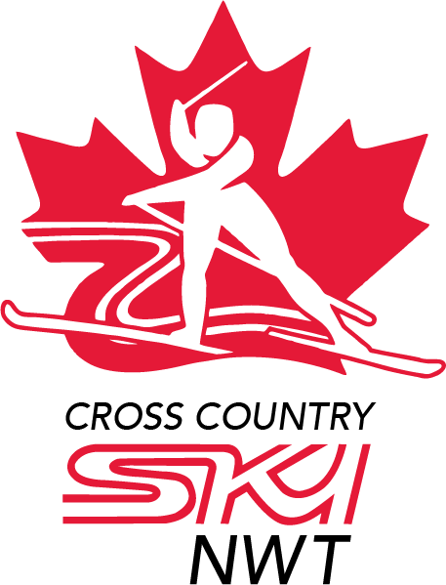
Cross Country NWT Annual General Meeting
Virtual Meeting
Monday, May 31, 2021
7:00 pm

Cross Country NWT
Mon, May 31, 2021 7:00 PM - 9:00 PM (MDT)

Shawne Kokelj, President
Tracey Pope
Angie Littlefair
John Stephenson, YK Club Rep
Tania Hercun, Consultant
Heather Scott, YK Alternate Club Rep
Kevin Smith, Fort Smith Club Rep
Julia Gyapay, Hay River Club Rep
Carolyn Hunter, Inuvik Club Rep
Sarah Pruys, Administrator
Ollie Williams, Administrator

Agenda Number | Agenda Item | Notes/Discussion/ Information | Decision/Action
1 | Call to Order
2 | Approval of Agenda | Additional Agenda Items: | Decision
3 | Approval of Minutes from 2020 AGM | Minutes, CCNWT AGM June 15, 2020 | Decision
4 | Report on 2020-2021 activities | - President’s Report  - Treasurer’s Report and Approval of Financial Statements  - Administrator’s Report  - Safe Sport | B. Decision  Approval of Financial statements
5 | Election or Appointment Board Members and Confirmation of Member Ski Club Representatives | - Vice-President  - Past President  - Treasurer  - Events & Communications Director  - Coach & Athlete Representative  - Member Club Representative  - Yellowknife Ski Club  - Fort Smith Ski Club and Nordic Centre  - Hay River Ski Club  - Inuvik Ski Club - reinstatement? | Decision  F.
6 | Adjourn
7
8

